230310 Meeting Minutes
Attendees: Saori Lobbia, Michelle Ravel, Marina Lecoeuche, Brianna Garcia, Jasmine Emtage, Melissa McPherson, Max Christman, Wen Chen, Kate Malecek, Yvette Garcia, Tasha Cammidge, Sarah Torres
Lunch from CAVA!
Introductions …
Monthly Tip
- Autoclaves use as much as 60-90 gallons of water per cycle, equivalent to running your shower for 45 minutes!
- By running autoclaves only when full, you not only reduce water waste but also save a huge amount of energy
- Consider
- Arranging a schedule for autoclaving with your lab
- Or sharing loads with other nearby labs to reduce running loads that are not full
- Talk with your building manager about replacing older models, or installing water-saving devices on autoclaves. You can learn more about autoclaves here, and how to make their use more efficient (for example: many can be turned off or put into standby mode when not in use).
Upcoming Conference for I2SL
- Conference is in October,
- Sarah and Tasha are submitting an abstract of our origin story adventure
Updates
- March Faculty Meeting
  - Thanks for all the feedback, it made a huge difference!
  - Went well – despite sound issues
  - Handed out little handouts (see bottom of notes) with links for the certification and website
  - David Warren said: “Thanks, Tasha & Sarah, and great presentation on Friday! You got the faculty’s attention, which is no easy feat.“
  - Added that we are inviting any lab that is certified before April 22 (Earth Day) to celebrate with a sweet treat
- Survey available for lab managers
  - Prize for completion is recycling bins and signage for their labs!
  - No one has responded yet, so we want to tie it into the Lomi’s which are coming soon, so email the lab managers about the lomis and in that email have survey and certification
- Regular spot for the BBE Newsletter!
- WiBBE Social Event(s)
  - WC very excited about this!
  - Set up a booth, bring a laptop to sign folks up and/or complete certification
  - Poster() with information about website, certification, Guides, meetings
  - Swag and a raffle at end of night for Rocketbook and/or swag bag
  - May do another event on sustainable female hygiene products
  - Showed our information QR code sheets (on drive) if anyone has anything else to add
- Lomis!
  - Coming soon (see above for discussion on engagement)
  - We want to make a cheat sheet on how to use them, ask facilities to move the compost to the dining center
    - MC said we might just be able to collaborate with the gardeners instead, if it makes compost anyway, he will email us about it
    - Asked for a volunteer for the second floor one (TC is B1 and ST is L3)
      - YG volunteered for L2!
- Samples
  - Polycarbin
    - We thought it was 100% recycled, but apparently not (KM indicated it was in the teens!) – sad
    - We asked people to try them, and some gave good feedback
    - KM wants to ask them more about their process but she is not convinced on their veracity, is reaching out to other schools who use them to get feedback
    - TC would like to hear more about this work, KM will stick around for after
  - Biobased conical tubes from Eppendorf
    - Biobased polymer made from 90 % renewable resources (e.g. waste and residues from vegetable oil refining or waste cooking oil) the product-related carbon footprint of these tubes was significantly reduced
    - Giving them out for folks to try
    - Currently very expensive, working with rep to get a discount
Update from OLAR – Melissa McPherson
- Transitioning OLAR to all biodegradable gloves
  - YG asked about using them with ethanol and MP said it was not a problem, so YG is more willing to test them out
  - Only running full autoclaves instead of running them before lunches etc!!!
    - Every one very excited about this
    - MC: GOOD WORK!
  - Doing a food study as MP noticed they were wasting a lot of food
    - Taking pictures of what it looks like for feeding one mouse, 5 mice etc
  - Bedding
    - Want to compost it but having a hard time
    - MC: he has also tried to convince companies, but it might be a hard sell for the bedding however they may be able to compost that food with Caltech – he will help reach out if they want to pursue (this is more likely than the bedding)
    - KM: Arlington gardens might be able to help out with accepting the bedding waste
Lightning Talk Event
- GOOGLE FORM FOR PEOPLE TO SIGN UP!!
  - So far only one person has signed up, they are awesome!
  - WC: can talk with Tish about signing up for campus calendar, she will email ST to do that
- Poster below in the doc
- Held April 28 (Earth Day is April 22nd)
  - Each talk is 3 minutes with time for questions
  - Projects their lab HAS done that has made them more efficient or sustainable
  - OR projects they would LIKE to do
  - We present on Green Labs and we can present a module or an initiative in our labs
- Presenters will be awarded a RocketBook!
- Attendees will be entered into a sustainable raffle!
- Submissions are open soon and accepted until ~April 14th
  - Asking folks to send an idea and slide(s) for their 3 minute talk
- Holding it in Chen 100 from 1-3 pm
- Sponsor
  - Have asked NEB – no response
  - Asked Genesee to host, they have agreed
    - Snacks/coffee/food
      - Where from?
      - Thinking lemonade, iced tea/coffee, pie, cookies etc
    - Some swag
    - Presentation
    - Booth?
    - Hosting a zero-waste event
      - Biodegradable cutlery and plates and cups
      - OR we encourage folks to bring their own cutlery and cups
      - Pop cans that are recyclable (not plastic!)
- Volunteers!
  - Help distributing the signs
    - WC mentioned they clean them off the first of the month, so go after that
      - We may have to put them up twice?
    - TC/ST can do this
  - Artwork for the whiteboard?
  - Other topics for presenters
    - ST: Dining center
      - MR interested in learning about this
  - Decide on the raffle
    - ST: bento box
    - YG: may have some extra cutlery she can donate – TC will follow up!
    - WC and others liked the bento box idea
    - YG: also might include other things like stasher bags and beeswax paper
  - Before event we need volunteers for
    - Organizing talks and slides - JE
      - TC/ST will receive them and forward them
    - Volunteers for Green Labs talks if not enough content
      - TC/ST will reach out if we don’t get enough talks
    - Email bbe-all with information?
    - Newsletter April 10th - TC will handle this
    - Facilitating the table delivery from facilities
      - Chen 100 has tables in the back we can use instead, so no volunteer
  - During the event we need volunteers for:
    - Setup and takedown of tables if needed
    - Organizing tables/spaces for food and vendor “booth” and GL “booth”- BG
      - We would like to try to do a zero-waste event, so we should promote that
    - A/V support - TC
    - Moderating the questions and keeping speakers on track - MR
    - Personning the Green Labs booth/area - ML
      - Have a Green Labs booth with laptops for folks to sign up or complete their certification
      - Grab bags with GL swag/samples
    - Picking up the food or being point person on food delivery if vendors are not bringing it themselves? – ST?
  - THANK YOU IN ADVANCE ALL VOLUNTEERS!!
Action Plan
- We would like to put names on projects
- TC is trying to be mindful of people’s time so going through it quickly
- People can sign up on the Drive
- We are also interested if there are other projects people would like to look into
- Recycling points – VK
  - Pipette box recycling points
  - Styrofoam recycling points – we need to figure out if we can even recycle Styrofoam here
  - Ice pack recycling
  - Recycling bin signage – VK??
    - Printer signage for eco-friendly printer usage
    - Recycling bins inside labs (so including petri dishes, excluding kimwipes etc) – this may be a collaboration with EHS
    - Recycling bins in the hallways of BBE to indicate how to recycle properly
    - This would be a collaboration with Facilities
  - Getting data
    - Genesee and USA Scientific have agreed to pick up their tip boxes FOR FREE
    - Vijaya has done research on some other vendors and found:
      - https://www.fishersci.com/shop/products/01000999/01000999
        - List price: $305/pack of 5
        - TechMart price: 195.43/pack of 5
        - Quote: $175/pack of 5
        - capacity: about 35-75 empty tip boxes ($0.46/box)
      - https://us.vwr.com/store/catalog/product.jsp?catalog_number=89234-732
        - List price: $645.07/pack of 5 (wow!)
        - Caltech price: the rep can work with us depending on order size
        - capacity: 113 empty tip boxes ($1.14/box)
      - not sustainable, way too costly
    - From VK (via email):
      - We could put boxes nearby labs to encourage recycling BUT this requires more volunteers
      - Order some plastic bins (~5?) (or just use boxes from shipping) and put one box per building and just have a general tip box recycling point
      - We want to collect data on how much volume per vendor we are getting for the duration of the project (say: 3 months).
      - Volunteers from our group would then collect the bins and bring them to Chen (we think we can ask Jesse for a spot here to collect the boxes) and sort them out once a week or so.
        - No one in meeting is super keen on collecting them and hauling the boxes across campus
          - YG and ST are ok with sorting if needs be
          - KM mentioned it might be hard to tell them apart without the packaging…?
        - MR suggested we could instead rent carts from “Darrel at Fedex”?
        - Can contact Robert from custodial services to see about rerouting tip boxes to Chen or something?
        - YG certain we can get that information from purchasing – she has access and can work with the system to get information that way instead
          - TC will send email to put them in touch
      - Could also purchase a plastic chipper
        - This would involve collaboration with custodians etc, need to make sure it could work with our plastics, maintenance costs, replacing it after some time etc
        - But we could sell the pellets!?
  - At the end of the year, we want to send our recommendations to the Provost/BBE leadership, and we would love to make this a cornerstone
  - Get funding from Caltech or LA county?
  - Leverage this to make purchasing Genesee/USA Sci easier, ask Caltech to make this more favorable, ask other vendors to participate for free like they do, etc
- Develop the Newcomer Welcome Guide, Welcome Package, and Survey Thank-yous
  - Related to GL Certification form, could tie in information in the Guides, help organize swag and distribute etc, includes signage discussed below
- Update GL Certification form with links, tips etc
- Chemical and equipment share program/email
- Pilot program
  - Especially editing and testing submission forms
  - Coordinating submissions, coordinating with faculty sponsors
- Inventory program
  - -80 freezers
  - Autoclaves
  - Fume Hoods
    - Coordinating volunteers to help with this, talking with lab managers or Jesse etc
    - Making spreadsheet and taking inventory in BBE
    - Standardized signage (for scheduling runs etc)
    - Talk with lab managers about scheduling fewer loads a week or collaborating with nearby labs to reduce runs etc
    - Making a map
    - Suggest empty or unused equipment be turned off (eg fume hoods)
    - Encouraging participation in the freezer challenge
- Freezer cleanout signage
  - “Stickers” or signs that promote the freezer challenge or participation in GL freezer stuff
  - “5 ways tips and tricks for keeping a green freezer” signage
  - A simple laminated sign (magnet?) that can be updated when the last cleanout was done or something like that
  - Examples at end of this document
- Energy Assessment – JL?
  - Tool for assessing how much energy your lab uses based on the equipment you have
  - Assess where your lab is “spending” energy, to inform decisions on how to manage usage
- Signage for equipment – Sami/TC
  - Already in the works, waiting on our amazing graphic designer, Sami, to send us finished versions
  - Will print stickers to give out in welcome packages etc
  - Group approves the stickers
    - MR – can print them at the tech hub in Caltech hall – ST and TC will look into!!
    - YG: make sure they are vinyl so they are able to be cleaned with EtOH
- Sustainable, fun projects to do with kids
  - Sock mammoth
- Zero-waste or sustainable events
  - Events Guide
    - Working with Brianna (who has started the Restaurant Guide)
    - This project would involve collecting resources for sustainable or zero-waste events
    - You may also want to collaborate with Brianna Garcia (see below), who is putting together the Sustainable Restaurant Guide
    - Help do the write-up
  - Restaurant Guide - BG
    - Gathering sustainable restaurants and putting them into a few documents (breakfast, lunch, dinner, that kind of thing)
    - We would LIKE to call each of the vendors she has found and see if they would be willing to give us a discount (10%?) for promoting them on GL
- For our graduate students
  - Incorporating green chemistry or other topics into curriculum for grad students
    - Cost effective
    - Easy for profs to adopt
    - Grad students get professional development, they can make slides or adjust slides or curriculum, teach a class
  - Reaching out to GSA?
  - CLTO workshops?
  - Victoria Orphan or other profs interested in sustainability?
  - Working with Pamela Bjorkman for the graduate course where you design your own curriculum and train other grad students?
  - Surveying students for interest multiple years in a row etc

Reminders:
- Freezer challenge!
  - www.freezerchallenge.org
  - Sign up, can participate not only in changing your -80 to -70, but can also clean them out, defrost, decommission, or reorganize/inventory your freezers
    - WHAT: The International Institute for Sustainable Laboratories (I2SL) and My Green Lab are partnering for the seventh year in a row to coordinate the International Laboratory Freezer Challenge. Designed to promote best practices in cold storage management for laboratories around the world, the Freezer Challenge harnesses a spirit of competition to achieve greater energy efficiency, sample integrity, and sample access.
    - WHO: All laboratories from all sectors that have cold storage.
    - WHEN: January 1 to July 1, 2023. Scoresheets will be accessible starting January 1. You can count any actions you’ve taken from August 1, 2022to July 1, 2023 on your scoresheet for points.
    - REGISTER: At www.freezerchallenge.org
    - COST: It’s free upon online registration AND you get to come to Green Lab’s popsicle party after the event!
- Certification!
  - Takes ½ hour
  - Very simple!
  - See https://greenlabs.caltech.edu for the form
  - Get a plaque!
  - Green Labs will give you bins and signage for your lab!
For next time
- Anything else?
  - MR mentioned incentivising using reusable cups at dining centers
    - ST mentioned they have only a .25c discount for bringing your own cup
    - TC: we can add this to our year-end report to increase this incentive
  - SL: wanted to know more about what can be recycled
    - TC will email her more information
    - Can recycle non-hazardous tips, conical tubes, tip boxes, petri dishes etc
      - SL: can you recycle serological pipettes
        - YG: no because they have the filters
        - KM: can talk more with PolyCarbin about what their recycling plans look like since their recycling boxes have serological pipettes advertised, but she is skeptical and is reaching out to other labs to see if they like and trust the service
  - WC: mentioned how cool it would be for Caltech to have a planter program (like this)
    - (from a later email to follow up): Also, I like the idea of garden towers that combine composts bin with planters. Here is an example: https://www.gardentowerproject.com/products/garden-tower-2-composting-container-garden
    - It will be really cool to have one inside the Chen building. Will need a couple of volunteers in charge though but whoever volunteers may own the harvest!
    - TC replied: I LOVE LOVE LOVE these towers, they look awesome! Perhaps we can have you apply for funding from our pilot program? I’ve attached the draft form here if you want to take a look. Can you have them inside? Maybe we can grow plants that can be used for an event or something (maybe pizza? Like if we grew basil and parsley etc) What do you think? Or perhaps folks/volunteers can claim a level for a few months or something and grow stuff, build community or something? Or a lab could have a level and use it for their lab events or something? Looking forward to hearing your thoughts! ❤ Great suggestion!

- Next meeting is 12pm April 14th (possibly in Chen 322?)
  - Bring a friend and get a rocketbook!
Leaflets”
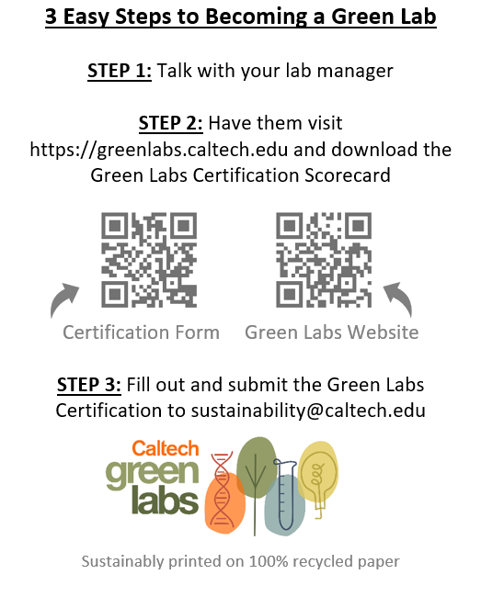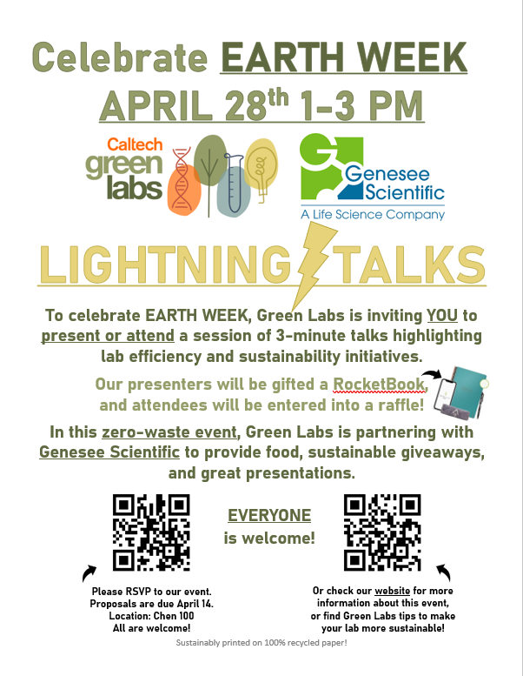
Lab signage for machines:
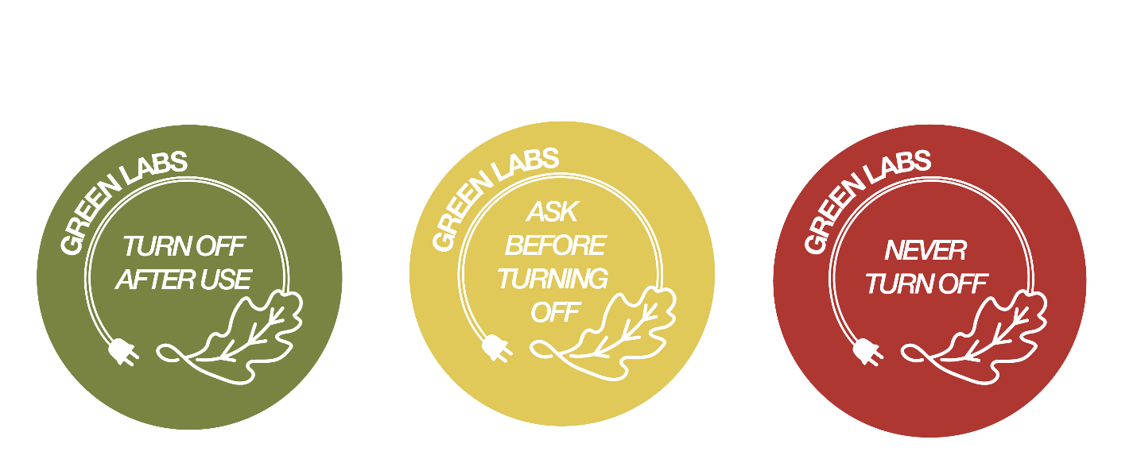

Freezer signage:

